Company Name

Book Subtitle

Book Title

|  |
| --- |
|  |

Table of Content

Introduction 5

This is the first Chapter 6

Sub Section 1 7

Sub Section 2 8

This is the second Chapter 9

This is the third Chapter 12

This is the forth Chapter 15

This is the fifth Chapter 18

This is the sixth Chapter 21

Images 24

Index 25

Bibliography 26

|  |
| --- |
|  |

# Introduction

A book is characterized by the following properties:

* A book has a minimum of about 25 pages and of about 5 sections.
* The density of text is high but the requirements on formatting are low.
* Bullet list like this one are quite rare in a book. Same is valid for tables.
* Graphics are rare in books, except for illustrated books.

There will be tables of contents / figures / tables in a book and at the end there may be an index and a bibliography. The bibliography collects all references used in the book like for example (1).

The document contains blind text.

|  |
| --- |
| Chapter  1 |

# This is the first Chapter

This is the sub title of the current chapter

B

ut I must explain to you how all this mistaken idea of denouncing pleasure and praising pain was born and I will give you a complete account of the system, and expound the actual teachings of the great explorer of the truth, the master-builder of human happiness.

No one rejects, dislikes, or avoids pleasure itself, because it is pleasure, but because those who do not know how to pursue pleasure rationally encounter consequences that are extremely painful.

Nor again is there anyone who loves or pursues or desires to obtain pain of itself, because it is pain, but because occasionally circumstances occur in which toil and pain can procure him some great pleasure.

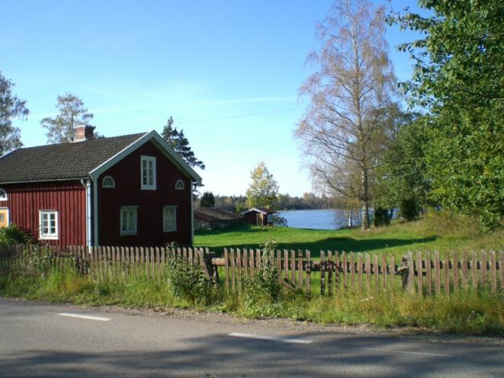

Image 1

To take a trivial example, which of us ever undertakes laborious physical exercise, except to obtain some advantage from it?

But who has any right to find fault with a man who chooses to enjoy a pleasure that has no annoying consequences or one who avoids a pain that produces no resultant pleasure?

On the other hand, we denounce with righteous indignation and dislike men who are so beguiled and demoralized by the charms of pleasure of the moment, so blinded by desire, that they cannot foresee the pain and trouble that are bound to ensue; and equal blame belongs to those who fail in their duty through weakness of will, which is the same as saying through shrinking from toil and pain.

But I must explain to you how all this mistaken idea of denouncing pleasure and praising pain was born and I will give you a complete account of the system, and expound the actual teachings of the great explorer of the truth, the master-builder of human happiness.

No one rejects, dislikes, or avoids pleasure itself, because it is pleasure, but because those who do not know how to pursue pleasure rationally encounter consequences that are extremely painful.

Nor again is there anyone who loves or pursues or desires to obtain pain of itself, because it is pain, but because occasionally circumstances occur in which toil and pain can procure him some great pleasure.

To take a trivial example, which of us ever undertakes laborious physical exercise, except to obtain some advantage from it?

But who has any right to find fault with a man who chooses to enjoy a pleasure that has no annoying consequences, or one who avoids a pain that produces no resultant pleasure?

## Sub Section 1

On the other hand, we denounce with righteous indignation and dislike men who are so beguiled and demoralized by the charms of pleasure of the moment, so blinded by desire, that they cannot foresee the pain and trouble that are bound to ensue; and equal blame belongs to those who fail in their duty through weakness of will, which is the same as saying through shrinking from toil and pain.

But I must explain to you how all this mistaken idea of denouncing pleasure and praising pain was born and I will give you a complete account of the system, and expound the actual teachings of the great explorer of the truth, the master-builder of human happiness.

No one rejects, dislikes, or avoids pleasure itself, because it is pleasure, but because those who do not know how to pursue pleasure rationally encounter consequences that are extremely painful.

Nor again is there anyone who loves or pursues or desires to obtain pain of itself, because it is pain, but because occasionally circumstances occur in which toil and pain can procure him some great pleasure.

To take a trivial example, which of us ever undertakes laborious physical exercise, except to obtain some advantage from it?

But who has any right to find fault with a man who chooses to enjoy a pleasure that has no annoying consequences or one who avoids a pain that produces no resultant pleasure?

On the other hand, we denounce with righteous indignation and dislike men who are so beguiled and demoralized by the charms of pleasure of the moment, so blinded by desire, that they cannot foresee the pain and trouble that are bound to ensue; and equal blame belongs to those who fail in their duty through weakness of will, which is the same as saying through shrinking from toil and pain.

## Sub Section 2

But I must explain to you how all this mistaken idea of denouncing pleasure and praising pain was born and I will give you a complete account of the system, and expound the actual teachings of the great explorer of the truth, the master-builder of human happiness.

No one rejects, dislikes, or avoids pleasure itself, because it is pleasure, but because those who do not know how to pursue pleasure rationally encounter consequences that are extremely painful.

Nor again is there anyone who loves or pursues or desires to obtain pain of itself, because it is pain, but because occasionally circumstances occur in which toil and pain can procure him some great pleasure.

To take a trivial example, which of us ever undertakes laborious physical exercise, except to obtain some advantage from it?

But who has any right to find fault with a man who chooses to enjoy a pleasure that has no annoying consequences, or one who avoids a pain that produces no resultant pleasure?

On the other hand, we denounce with righteous indignation and dislike men who are so beguiled and demoralized by the charms of pleasure of the moment, so blinded by desire, that they cannot foresee the pain and trouble that are bound to ensue; and equal blame belongs to those who fail in their duty through weakness of will, which is the same as saying through shrinking from toil and pain.

|  |
| --- |
| Chapter  2 |

# This is the second Chapter

This is the sub title of the current chapter

B

ut I must explain to you how all this mistaken idea of denouncing pleasure and praising pain was born and I will give you a complete account of the system, and expound the actual teachings of the great explorer of the truth, the master-builder of human happiness.

No one rejects, dislikes, or avoids pleasure itself, because it is pleasure, but because those who do not know how to pursue pleasure rationally encounter consequences that are extremely painful.

Nor again is there anyone who loves or pursues or desires to obtain pain of itself, because it is pain, but because occasionally circumstances occur in which toil and pain can procure him some great pleasure.

To take a trivial example, which of us ever undertakes laborious physical exercise, except to obtain some advantage from it?

But who has any right to find fault with a man who chooses to enjoy a pleasure that has no annoying consequences or one who avoids a pain that produces no resultant pleasure?

On the other hand, we denounce with righteous indignation and dislike men who are so beguiled and demoralized by the charms of pleasure of the moment, so blinded by desire, that they cannot foresee the pain and trouble that are bound to ensue; and equal blame belongs to those who fail in their duty through weakness of will, which is the same as saying through shrinking from toil and pain.

But I must explain to you how all this mistaken idea of denouncing pleasure and praising pain was born and I will give you a complete account of the system, and expound the actual teachings of the great explorer of the truth, the master-builder of human happiness.

No one rejects, dislikes, or avoids pleasure itself, because it is pleasure, but because those who do not know how to pursue pleasure rationally encounter consequences that are extremely painful.

Nor again is there anyone who loves or pursues or desires to obtain pain of itself, because it is pain, but because occasionally circumstances occur in which toil and pain can procure him some great pleasure.

To take a trivial example, which of us ever undertakes laborious physical exercise, except to obtain some advantage from it?

But who has any right to find fault with a man who chooses to enjoy a pleasure that has no annoying consequences, or one who avoids a pain that produces no resultant pleasure?

On the other hand, we denounce with righteous indignation and dislike men who are so beguiled and demoralized by the charms of pleasure of the moment, so blinded by desire, that they cannot foresee the pain and trouble that are bound to ensue; and equal blame belongs to those who fail in their duty through weakness of will, which is the same as saying through shrinking from toil and pain.

But I must explain to you how all this mistaken idea of denouncing pleasure and praising pain was born and I will give you a complete account of the system, and expound the actual teachings of the great explorer of the truth, the master-builder of human happiness.

No one rejects, dislikes, or avoids pleasure itself, because it is pleasure, but because those who do not know how to pursue pleasure rationally encounter consequences that are extremely painful.

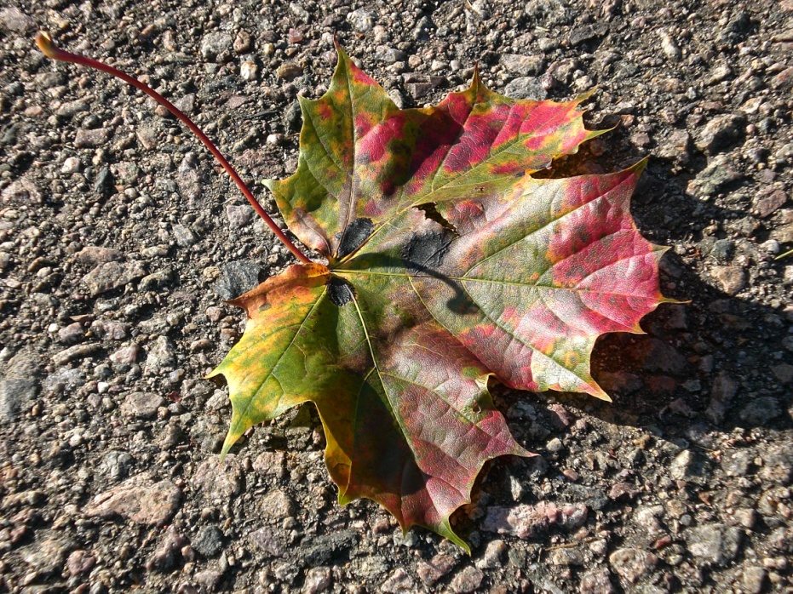

Image 2

Nor again is there anyone who loves or pursues or desires to obtain pain of itself, because it is pain, but because occasionally circumstances occur in which toil and pain can procure him some great pleasure.

To take a trivial example, which of us ever undertakes laborious physical exercise, except to obtain some advantage from it?

But who has any right to find fault with a man who chooses to enjoy a pleasure that has no annoying consequences or one who avoids a pain that produces no resultant pleasure?

On the other hand, we denounce with righteous indignation and dislike men who are so beguiled and demoralized by the charms of pleasure of the moment, so blinded by desire, that they cannot foresee the pain and trouble that are bound to ensue; and equal blame belongs to those who fail in their duty through weakness of will, which is the same as saying through shrinking from toil and pain.

But I must explain to you how all this mistaken idea of denouncing pleasure and praising pain was born and I will give you a complete account of the system, and expound the actual teachings of the great explorer of the truth, the master-builder of human happiness.

No one rejects, dislikes, or avoids pleasure itself, because it is pleasure, but because those who do not know how to pursue pleasure rationally encounter consequences that are extremely painful.

Nor again is there anyone who loves or pursues or desires to obtain pain of itself, because it is pain, but because occasionally circumstances occur in which toil and pain can procure him some great pleasure.

To take a trivial example, which of us ever undertakes laborious physical exercise, except to obtain some advantage from it?

But who has any right to find fault with a man who chooses to enjoy a pleasure that has no annoying consequences, or one who avoids a pain that produces no resultant pleasure?

On the other hand, we denounce with righteous indignation and dislike men who are so beguiled and demoralized by the charms of pleasure of the moment, so blinded by desire, that they cannot foresee the pain and trouble that are bound to ensue; and equal blame belongs to those who fail in their duty through weakness of will, which is the same as saying through shrinking from toil and pain.

|  |
| --- |
| Chapter  3 |

# This is the third Chapter

This is the sub title of the current chapter

B

ut I must explain to you how all this mistaken idea of denouncing pleasure and praising pain was born and I will give you a complete account of the system, and expound the actual teachings of the great explorer of the truth, the master-builder of human happiness.

No one rejects, dislikes, or avoids pleasure itself, because it is pleasure, but because those who do not know how to pursue pleasure rationally encounter consequences that are extremely painful.

Nor again is there anyone who loves or pursues or desires to obtain pain of itself, because it is pain, but because occasionally circumstances occur in which toil and pain can procure him some great pleasure.

To take a trivial example, which of us ever undertakes laborious physical exercise, except to obtain some advantage from it?

But who has any right to find fault with a man who chooses to enjoy a pleasure that has no annoying consequences or one who avoids a pain that produces no resultant pleasure?

On the other hand, we denounce with righteous indignation and dislike men who are so beguiled and demoralized by the charms of pleasure of the moment, so blinded by desire, that they cannot foresee the pain and trouble that are bound to ensue; and equal blame belongs to those who fail in their duty through weakness of will, which is the same as saying through shrinking from toil and pain.

But I must explain to you how all this mistaken idea of denouncing pleasure and praising pain was born and I will give you a complete account of the system, and expound the actual teachings of the great explorer of the truth, the master-builder of human happiness.

No one rejects, dislikes, or avoids pleasure itself, because it is pleasure, but because those who do not know how to pursue pleasure rationally encounter consequences that are extremely painful.

Nor again is there anyone who loves or pursues or desires to obtain pain of itself, because it is pain, but because occasionally circumstances occur in which toil and pain can procure him some great pleasure.

To take a trivial example, which of us ever undertakes laborious physical exercise, except to obtain some advantage from it?

But who has any right to find fault with a man who chooses to enjoy a pleasure that has no annoying consequences, or one who avoids a pain that produces no resultant pleasure?

On the other hand, we denounce with righteous indignation and dislike men who are so beguiled and demoralized by the charms of pleasure of the moment, so blinded by desire, that they cannot foresee the pain and trouble that are bound to ensue; and equal blame belongs to those who fail in their duty through weakness of will, which is the same as saying through shrinking from toil and pain.

But I must explain to you how all this mistaken idea of denouncing pleasure and praising pain was born and I will give you a complete account of the system, and expound the actual teachings of the great explorer of the truth, the master-builder of human happiness.

No one rejects, dislikes, or avoids pleasure itself, because it is pleasure, but because those who do not know how to pursue pleasure rationally encounter consequences that are extremely painful.

Nor again is there anyone who loves or pursues or desires to obtain pain of itself, because it is pain, but because occasionally circumstances occur in which toil and pain can procure him some great pleasure.

To take a trivial example, which of us ever undertakes laborious physical exercise, except to obtain some advantage from it?

But who has any right to find fault with a man who chooses to enjoy a pleasure that has no annoying consequences or one who avoids a pain that produces no resultant pleasure?

On the other hand, we denounce with righteous indignation and dislike men who are so beguiled and demoralized by the charms of pleasure of the moment, so blinded by desire, that they cannot foresee the pain and trouble that are bound to ensue; and equal blame belongs to those who fail in their duty through weakness of will, which is the same as saying through shrinking from toil and pain.

But I must explain to you how all this mistaken idea of denouncing pleasure and praising pain was born and I will give you a complete account of the system, and expound the actual teachings of the great explorer of the truth, the master-builder of human happiness.

No one rejects, dislikes, or avoids pleasure itself, because it is pleasure, but because those who do not know how to pursue pleasure rationally encounter consequences that are extremely painful.

Nor again is there anyone who loves or pursues or desires to obtain pain of itself, because it is pain, but because occasionally circumstances occur in which toil and pain can procure him some great pleasure.

To take a trivial example, which of us ever undertakes laborious physical exercise, except to obtain some advantage from it?

But who has any right to find fault with a man who chooses to enjoy a pleasure that has no annoying consequences, or one who avoids a pain that produces no resultant pleasure?

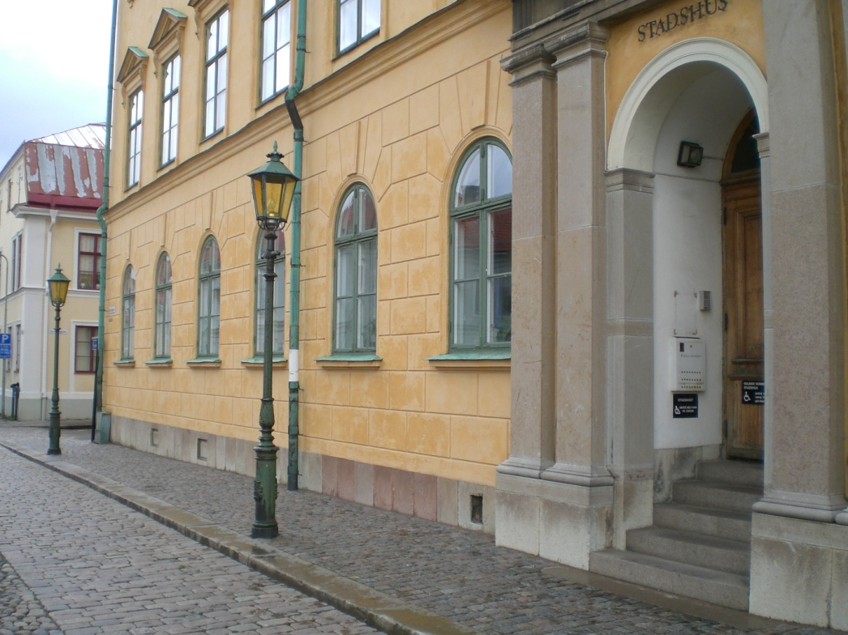

Image 3

On the other hand, we denounce with righteous indignation and dislike men who are so beguiled and demoralized by the charms of pleasure of the moment, so blinded by desire, that they cannot foresee the pain and trouble that are bound to ensue; and equal blame belongs to those who fail in their duty through weakness of will, which is the same as saying through shrinking from toil and pain.

|  |
| --- |
| Chapter  4 |

# This is the forth Chapter

This is the sub title of the current chapter

B

ut I must explain to you how all this mistaken idea of denouncing pleasure and praising pain was born and I will give you a complete account of the system, and expound the actual teachings of the great explorer of the truth, the master-builder of human happiness.

No one rejects, dislikes, or avoids pleasure itself, because it is pleasure, but because those who do not know how to pursue pleasure rationally encounter consequences that are extremely painful.

Nor again is there anyone who loves or pursues or desires to obtain pain of itself, because it is pain, but because occasionally circumstances occur in which toil and pain can procure him some great pleasure.

To take a trivial example, which of us ever undertakes laborious physical exercise, except to obtain some advantage from it?

But who has any right to find fault with a man who chooses to enjoy a pleasure that has no annoying consequences or one who avoids a pain that produces no resultant pleasure?

On the other hand, we denounce with righteous indignation and dislike men who are so beguiled and demoralized by the charms of pleasure of the moment, so blinded by desire, that they cannot foresee the pain and trouble that are bound to ensue; and equal blame belongs to those who fail in their duty through weakness of will, which is the same as saying through shrinking from toil and pain.

But I must explain to you how all this mistaken idea of denouncing pleasure and praising pain was born and I will give you a complete account of the system, and expound the actual teachings of the great explorer of the truth, the master-builder of human happiness.

No one rejects, dislikes, or avoids pleasure itself, because it is pleasure, but because those who do not know how to pursue pleasure rationally encounter consequences that are extremely painful.

Nor again is there anyone who loves or pursues or desires to obtain pain of itself, because it is pain, but because occasionally circumstances occur in which toil and pain can procure him some great pleasure.

To take a trivial example, which of us ever undertakes laborious physical exercise, except to obtain some advantage from it?

But who has any right to find fault with a man who chooses to enjoy a pleasure that has no annoying consequences, or one who avoids a pain that produces no resultant pleasure?

On the other hand, we denounce with righteous indignation and dislike men who are so beguiled and demoralized by the charms of pleasure of the moment, so blinded by desire, that they cannot foresee the pain and trouble that are bound to ensue; and equal blame belongs to those who fail in their duty through weakness of will, which is the same as saying through shrinking from toil and pain.

But I must explain to you how all this mistaken idea of denouncing pleasure and praising pain was born and I will give you a complete account of the system, and expound the actual teachings of the great explorer of the truth, the master-builder of human happiness.

No one rejects, dislikes, or avoids pleasure itself, because it is pleasure, but because those who do not know how to pursue pleasure rationally encounter consequences that are extremely painful.

Nor again is there anyone who loves or pursues or desires to obtain pain of itself, because it is pain, but because occasionally circumstances occur in which toil and pain can procure him some great pleasure.

To take a trivial example, which of us ever undertakes laborious physical exercise, except to obtain some advantage from it?

But who has any right to find fault with a man who chooses to enjoy a pleasure that has no annoying consequences or one who avoids a pain that produces no resultant pleasure?

On the other hand, we denounce with righteous indignation and dislike men who are so beguiled and demoralized by the charms of pleasure of the moment, so blinded by desire, that they cannot foresee the pain and trouble that are bound to ensue; and equal blame belongs to those who fail in their duty through weakness of will, which is the same as saying through shrinking from toil and pain.

But I must explain to you how all this mistaken idea of denouncing pleasure and praising pain was born and I will give you a complete account of the system, and expound the actual teachings of the great explorer of the truth, the master-builder of human happiness.

No one rejects, dislikes, or avoids pleasure itself, because it is pleasure, but because those who do not know how to pursue pleasure rationally encounter consequences that are extremely painful.

Nor again is there anyone who loves or pursues or desires to obtain pain of itself, because it is pain, but because occasionally circumstances occur in which toil and pain can procure him some great pleasure.

To take a trivial example, which of us ever undertakes laborious physical exercise, except to obtain some advantage from it?

But who has any right to find fault with a man who chooses to enjoy a pleasure that has no annoying consequences, or one who avoids a pain that produces no resultant pleasure?

On the other hand, we denounce with righteous indignation and dislike men who are so beguiled and demoralized by the charms of pleasure of the moment, so blinded by desire, that they cannot foresee the pain and trouble that are bound to ensue; and equal blame belongs to those who fail in their duty through weakness of will, which is the same as saying through shrinking from toil and pain.

|  |
| --- |
| Chapter  5 |

# This is the fifth Chapter

This is the sub title of the current chapter

B

ut I must explain to you how all this mistaken idea of denouncing pleasure and praising pain was born and I will give you a complete account of the system, and expound the actual teachings of the great explorer of the truth, the master-builder of human happiness.

No one rejects, dislikes, or avoids pleasure itself, because it is pleasure, but because those who do not know how to pursue pleasure rationally encounter consequences that are extremely painful.

Nor again is there anyone who loves or pursues or desires to obtain pain of itself, because it is pain, but because occasionally circumstances occur in which toil and pain can procure him some great pleasure.

To take a trivial example, which of us ever undertakes laborious physical exercise, except to obtain some advantage from it?

But who has any right to find fault with a man who chooses to enjoy a pleasure that has no annoying consequences or one who avoids a pain that produces no resultant pleasure?

On the other hand, we denounce with righteous indignation and dislike men who are so beguiled and demoralized by the charms of pleasure of the moment, so blinded by desire, that they cannot foresee the pain and trouble that are bound to ensue; and equal blame belongs to those who fail in their duty through weakness of will, which is the same as saying through shrinking from toil and pain.

But I must explain to you how all this mistaken idea of denouncing pleasure and praising pain was born and I will give you a complete account of the system, and expound the actual teachings of the great explorer of the truth, the master-builder of human happiness.

No one rejects, dislikes, or avoids pleasure itself, because it is pleasure, but because those who do not know how to pursue pleasure rationally encounter consequences that are extremely painful.

Nor again is there anyone who loves or pursues or desires to obtain pain of itself, because it is pain, but because occasionally circumstances occur in which toil and pain can procure him some great pleasure.

To take a trivial example, which of us ever undertakes laborious physical exercise, except to obtain some advantage from it?

But who has any right to find fault with a man who chooses to enjoy a pleasure that has no annoying consequences, or one who avoids a pain that produces no resultant pleasure?

On the other hand, we denounce with righteous indignation and dislike men who are so beguiled and demoralized by the charms of pleasure of the moment, so blinded by desire, that they cannot foresee the pain and trouble that are bound to ensue; and equal blame belongs to those who fail in their duty through weakness of will, which is the same as saying through shrinking from toil and pain.

But I must explain to you how all this mistaken idea of denouncing pleasure and praising pain was born and I will give you a complete account of the system, and expound the actual teachings of the great explorer of the truth, the master-builder of human happiness.

No one rejects, dislikes, or avoids pleasure itself, because it is pleasure, but because those who do not know how to pursue pleasure rationally encounter consequences that are extremely painful.

Nor again is there anyone who loves or pursues or desires to obtain pain of itself, because it is pain, but because occasionally circumstances occur in which toil and pain can procure him some great pleasure.

To take a trivial example, which of us ever undertakes laborious physical exercise, except to obtain some advantage from it?

But who has any right to find fault with a man who chooses to enjoy a pleasure that has no annoying consequences or one who avoids a pain that produces no resultant pleasure?

On the other hand, we denounce with righteous indignation and dislike men who are so beguiled and demoralized by the charms of pleasure of the moment, so blinded by desire, that they cannot foresee the pain and trouble that are bound to ensue; and equal blame belongs to those who fail in their duty through weakness of will, which is the same as saying through shrinking from toil and pain.

But I must explain to you how all this mistaken idea of denouncing pleasure and praising pain was born and I will give you a complete account of the system, and expound the actual teachings of the great explorer of the truth, the master-builder of human happiness.

No one rejects, dislikes, or avoids pleasure itself, because it is pleasure, but because those who do not know how to pursue pleasure rationally encounter consequences that are extremely painful.

Nor again is there anyone who loves or pursues or desires to obtain pain of itself, because it is pain, but because occasionally circumstances occur in which toil and pain can procure him some great pleasure.

To take a trivial example, which of us ever undertakes laborious physical exercise, except to obtain some advantage from it?

But who has any right to find fault with a man who chooses to enjoy a pleasure that has no annoying consequences, or one who avoids a pain that produces no resultant pleasure?

On the other hand, we denounce with righteous indignation and dislike men who are so beguiled and demoralized by the charms of pleasure of the moment, so blinded by desire, that they cannot foresee the pain and trouble that are bound to ensue; and equal blame belongs to those who fail in their duty through weakness of will, which is the same as saying through shrinking from toil and pain.

|  |
| --- |
| Chapter  6 |

# This is the sixth Chapter

This is the sub title of the current chapter

B

ut I must explain to you how all this mistaken idea of denouncing pleasure and praising pain was born and I will give you a complete account of the system, and expound the actual teachings of the great explorer of the truth, the master-builder of human happiness.

No one rejects, dislikes, or avoids pleasure itself, because it is pleasure, but because those who do not know how to pursue pleasure rationally encounter consequences that are extremely painful.

Nor again is there anyone who loves or pursues or desires to obtain pain of itself, because it is pain, but because occasionally circumstances occur in which toil and pain can procure him some great pleasure.

To take a trivial example, which of us ever undertakes laborious physical exercise, except to obtain some advantage from it?

But who has any right to find fault with a man who chooses to enjoy a pleasure that has no annoying consequences or one who avoids a pain that produces no resultant pleasure?

On the other hand, we denounce with righteous indignation and dislike men who are so beguiled and demoralized by the charms of pleasure of the moment, so blinded by desire, that they cannot foresee the pain and trouble that are bound to ensue; and equal blame belongs to those who fail in their duty through weakness of will, which is the same as saying through shrinking from toil and pain.

But I must explain to you how all this mistaken idea of denouncing pleasure and praising pain was born and I will give you a complete account of the system, and expound the actual teachings of the great explorer of the truth, the master-builder of human happiness.

No one rejects, dislikes, or avoids pleasure itself, because it is pleasure, but because those who do not know how to pursue pleasure rationally encounter consequences that are extremely painful.

Nor again is there anyone who loves or pursues or desires to obtain pain of itself, because it is pain, but because occasionally circumstances occur in which toil and pain can procure him some great pleasure.

To take a trivial example, which of us ever undertakes laborious physical exercise, except to obtain some advantage from it?

But who has any right to find fault with a man who chooses to enjoy a pleasure that has no annoying consequences, or one who avoids a pain that produces no resultant pleasure?

On the other hand, we denounce with righteous indignation and dislike men who are so beguiled and demoralized by the charms of pleasure of the moment, so blinded by desire, that they cannot foresee the pain and trouble that are bound to ensue; and equal blame belongs to those who fail in their duty through weakness of will, which is the same as saying through shrinking from toil and pain.

But I must explain to you how all this mistaken idea of denouncing pleasure and praising pain was born and I will give you a complete account of the system, and expound the actual teachings of the great explorer of the truth, the master-builder of human happiness.

No one rejects, dislikes, or avoids pleasure itself, because it is pleasure, but because those who do not know how to pursue pleasure rationally encounter consequences that are extremely painful.

Nor again is there anyone who loves or pursues or desires to obtain pain of itself, because it is pain, but because occasionally circumstances occur in which toil and pain can procure him some great pleasure.

To take a trivial example, which of us ever undertakes laborious physical exercise, except to obtain some advantage from it?

But who has any right to find fault with a man who chooses to enjoy a pleasure that has no annoying consequences or one who avoids a pain that produces no resultant pleasure?

On the other hand, we denounce with righteous indignation and dislike men who are so beguiled and demoralized by the charms of pleasure of the moment, so blinded by desire, that they cannot foresee the pain and trouble that are bound to ensue; and equal blame belongs to those who fail in their duty through weakness of will, which is the same as saying through shrinking from toil and pain.

But I must explain to you how all this mistaken idea of denouncing pleasure and praising pain was born and I will give you a complete account of the system, and expound the actual teachings of the great explorer of the truth, the master-builder of human happiness.

No one rejects, dislikes, or avoids pleasure itself, because it is pleasure, but because those who do not know how to pursue pleasure rationally encounter consequences that are extremely painful.

Nor again is there anyone who loves or pursues or desires to obtain pain of itself, because it is pain, but because occasionally circumstances occur in which toil and pain can procure him some great pleasure.

To take a trivial example, which of us ever undertakes laborious physical exercise, except to obtain some advantage from it?

But who has any right to find fault with a man who chooses to enjoy a pleasure that has no annoying consequences, or one who avoids a pain that produces no resultant pleasure?

On the other hand, we denounce with righteous indignation and dislike men who are so beguiled and demoralized by the charms of pleasure of the moment, so blinded by desire, that they cannot foresee the pain and trouble that are bound to ensue; and equal blame belongs to those who fail in their duty through weakness of will, which is the same as saying through shrinking from toil and pain.

# Images

Image 1 6

Image 2 10

Image 3 14

# Index

chapter 6

consequences 6

document 5

happiness. 6

human 6

index 5

# Bibliography

1. **Author, Name.** Title of referenced article. *Journal name.* 20xx, Vols. 20xx-1.